**Agenda Item: 2/01**

**= application site**

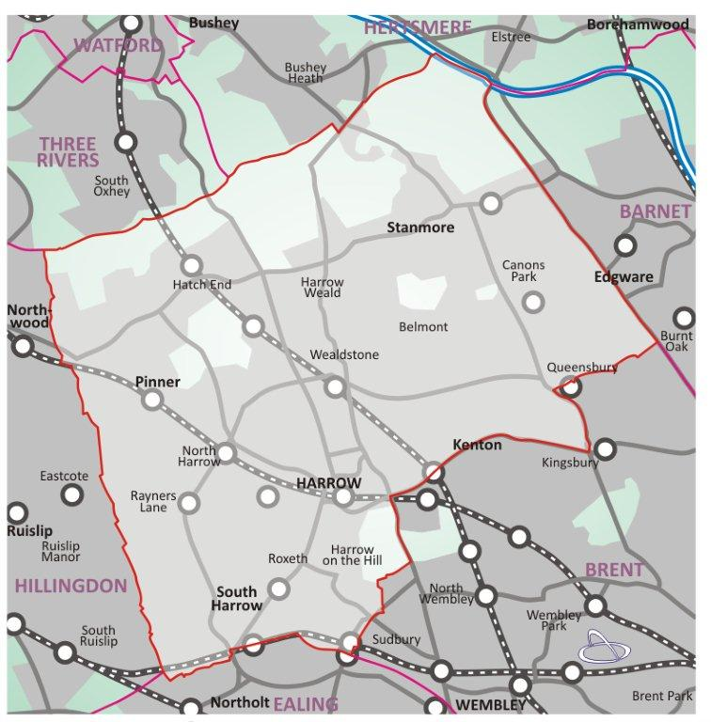

|  |  |
| --- | --- |
| **22 Hawthorn Drive, Harrow, HA2 7NX** | **P/3789/22** |

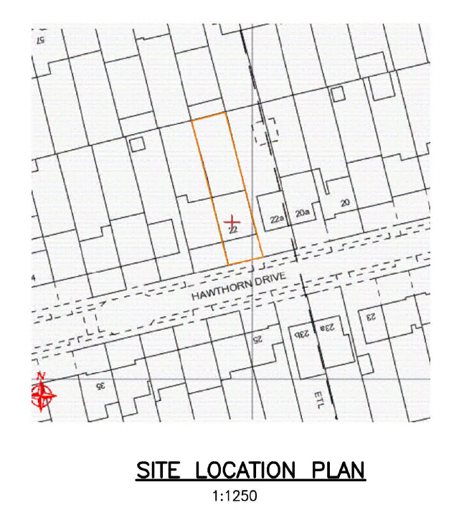

**LONDON BOROUGH OF HARROW**

**PLANNING COMMITTEE**

**18th January 2023**

|  |  |
| --- | --- |
| **APPLICATION NUMBER:** | P/3789/22 |
| **VALID DATE:** | 02/11/2022 |
| **LOCATION:** | 22 HAWTHORN DRIVE, HARROW |
| **WARD:** | NORTH HARROW |
| **POSTCODE:** | HA2 7NX |
| **APPLICANT:** | MR G ALI |
| **AGENT:** | KDA DESIGNS LTD |
| **CASE OFFICER:** | HAYDEN PARKER |
| **EXPIRY DATE:**  **EXTENSION OF TIME:** | 28/12/2022  N/A |

**PROPOSAL**

CERTIFICATE OF LAWFUL DEVELOPMENT (PROPOSED): Alterations and extension to roof to form end gable; rear dormer; two rooflights in front roof slope; window in end gable.

**RECOMMENDATION**

The Planning Committee is asked to:

1. Agree the reasons for approval as set out in this report, and
2. Grant certificate of lawful proposed development

**REASON FOR THE RECOMMENDATION**

The proportions of the extension are considered acceptable by default on both character and residential amenity grounds by virtue of compliance withSchedule 2, Part 1, Classes B & C of the Town and Country Planning (General Permitted Development) (England) Order 2015 (as amended).

**INFORMATION**

This application is reported to Planning Committee as it regards land in which a member has an interest and therefore falls within proviso C. (iii) of the Scheme of Delegation.

|  |  |
| --- | --- |
| Statutory Return Type: | Certificate of Proposed Lawful Development. |
| Council Interest:  Net additional volume: | None  46.58sqm |
| GLA Community Infrastructure Levy (CIL) Contribution (provisional): | N/A |
| Local CIL requirement: | N/A |

1. **SITE DESCRIPTION**

1.1 The subject site features a two-storey semi-detached dwellinghouse. The dwelling features a single width porch extension with a flat roof. The site features parking within the front forecourt and a garden in the rear.

1.2 The adjoining semi is No. 24 Hawthorn Drive. The building is similar in appearance aside from the garage, which has undergone alterations since the original building was constructed. Alike the subject site, No. 24 features parking within the front forecourt.

1.3 No. 22a Hawthorn Drive abuts the subject site in the east. The site features a single storey semi-detached dwelling. There is a large powerline in the rear garden of the site, which spans into the adjoining property at No. 20 Hawthorn Drive.

1.4 The subject site is not a listed building or located within a conservation area.

**2.0 PROPOSAL**

2.1 Alterations and extension to roof to form end gable: rear dormer. The rear dormer extension seeks a maximum height from the existing roof form of 2.57m and a depth of 3.6m. Two rooflights are also proposed to be located within the front roof slope and a window in the end gable.

**3.0 RELEVANT PLANNING HISTORY**

|  |  |  |
| --- | --- | --- |
| **LBH/43966** | Single storey rear and front porch extensions | **Grant: 13/12/1991** |

3.1Site History Context

3.2 There is no relevant history to the site that aligns with the proposal.

**4.0 CONSULTATION**

4.1 The application is for a certificate of proposed lawful development, whereby consultation to adjoining properties is not required.

4.2 Statutory and non-statutory consultation

4.3 No internal or external consultees were consulted on the application.

**5.0 POLICIES**

5.1 Schedule 2, Part 1, Classes B & C of the Town and Country Planning (General Permitted Development) (England) Order 2015 (as amended).

1. **ASSESSMENT**

6.1 The main issues are:

* Compliance with Class B – Additions etc to the roof
* Compliance with Class C - Other alterations to the roof of a dwellinghouse

**6.2 Compliance with permitted development (Classes B and C)**

6.2.1 The relevant policies are:

* Schedule 2, Part 1, Classes B & C of the Town and Country Planning (General Permitted Development) (England) Order 2015 (as amended).

6.2.2 The proposed hip to gable and rear dormer roof extension would have a volume of 46.58 cubic metres and is therefore within the 50 cubic metres limit for the enlargement of the roofs of semi-detached dwellinghouses. The proposed dormer would be set 200mm up the rear roof slope from the eaves of the original roof.

6.2.3 The proposed roof extensions would not at any point exceed the highest point of the existing roof. The proposed roof extensions would not project forward of any roof slope which forms the principal elevation of the dwellinghouse and fronts a highway.

6.2.4 The proposed roof extensions would not include the provision of a veranda, balcony or raised platform or the installation, alteration or replacement of a chimney, flue or soil, vent pipe, solar photovoltaic or solar thermal equipment.

6.2.5 The materials to be used in any exterior work shall be of a similar appearance to those used in the construction of the exterior of the existing dwellinghouse.

6.2.6 The proposed roof extensions would be built entirely within the curtilage of the property. There are no planning conditions removing permitted development rights or any other relevant developments on the land.

6.2.7 The proposed window to the staircase will be obscured and will not be openable below 1.7m above floor level (C.2 (i) & (ii)).

6.2.8 The proposed end gable and rear dormer are within the tolerances of Classes B & C of Schedule 2, Part 1 of The Town and Country Planning (General Permitted Development) Order 1995 as amended by The Town and Country Planning (General Permitted Development) (England) Order 2015 (as amended). The proposal is therefore a lawful development.

**7.0 CONCLUSION AND REASONS FOR APPROVAL**

7.1 Officers are satisfied that the overall design of the extension, proposed external finishes and fenestration arrangements would not unduly detract from the character and appearance of the host dwelling, street scene and area in a wider context.

7.2 The proposal sought is consistent with the requirements of Schedule 2, Part 1, Classes B & C of the Town and Country Planning (General Permitted Development) (England) Order 2015 (as amended) and is therefore lawful.

**APPENIDIX 1: CONDITIONS AND INFORMATIVES**

**Conditions**

1. The proposal would be within the tolerances of Schedule 2, Part 1 Classes B & C of The Town and Country Planning (General Permitted Development) (England) Order 2015 (as amended).
2. The proposal is therefore a lawful development

**Informatives:**

1. The applicant's attention is drawn to the requirements in the Considerate Contractor Code of Practice. In the interests of minimising any adverse effects arising from building operations, the limitations on hours of working are as follows:

* 0800-1800 hours Monday - Friday (not including Bank Holidays)
* 0800-1300 hours Saturday.

1. The Party Wall etc. Act 1996 requires a building owner to notify and obtain formal agreement from adjoining owner(s) where the building owner intends to carry out building work which involves:

1. work on an existing wall shared with another property;

2. building on the boundary with a neighbouring property;

3. excavating near a neighbouring building, and that work falls within the scope of the Act.

Procedures under this Act are quite separate from the need for planning permission or building regulations approval.

"The Party Wall etc. Act 1996: explanatory booklet" is available free of charge from:

Communities and Local Government Publications, PO Box 236, Wetherby, LS23 7NB

Please quote Product code: 02 BR 00862 when ordering.

Also available for download from the Portal website:

<https://www.gov.uk/party-wall-etc-act-1996-guidance>

1. You should be aware that, whereas a planning permission is valid for three years, a Certificate is only valid for as long as the permitted development legislation that gave rise to the decision remains in place. This could mean that, if the legislation changes after the Certificate was determined, your proposals may no longer be permitted development. In this case this Certificate decision was based on the revised permitted development rights for householders that the Government brought into effect on 15 April 2015.

For further advice on the current householder permitted development guidance an interactive guide is available on the Planning Portal on: <http://www.planningportal.gov.uk/permission/house>

1. The applicant is advised to ensure that the highway is not interfered with or obstructed at any time during the execution of any works on land adjacent to a highway. The applicant is liable for any damage caused to any footway, footpath, grass verge, vehicle crossing, carriageway or highway asset. Please report any damage to nrswa@harrow.gov.uk or telephone 020 8424 1884 where assistance with the repair of the damage is available, at the applicant’s expense. Failure to report any damage could result in a charge being levied against the property.
2. The applicant is advised that this Certificate is issued on the basis that the submitted plans and information are a true representation of the site circumstances and on the assumption that the property is in use as a single family dwellinghouse. If later this information turns out to be incorrect, then the basis of this Certificate may be challenged and the development could be liable to enforcement action.
3. The applicant is advised that the Drainage Authority in Harrow recommends the submission for their approval of a drainage plan indicating all surface and foul water connections and their outfall details. Please also note that separate systems are used in Harrow for surface water and foul water discharge. Please email [infrastructure@harrow.gov.uk](mailto:infrastructure@harrow.gov.uk) with your plans.

Checked

|  |  |
| --- | --- |
| Mehdi Rezaie  Head of Development Management (Interim)  22nd December 2022 | Viv Evans  Chief Planning Officer  22nd December 2022 |

**APPENDIX 2: LOCATION PLAN**



**APPENDIX 3: PLANS AND ELEVATIONS**

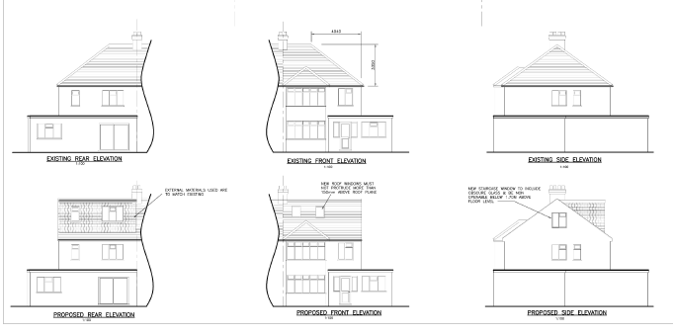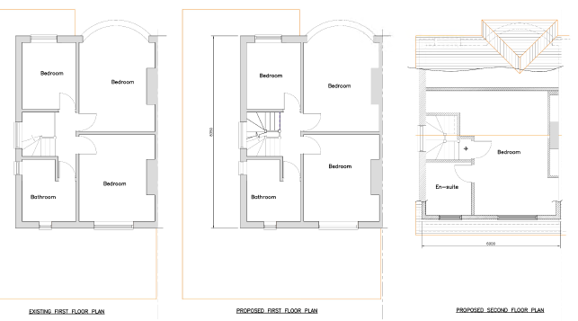

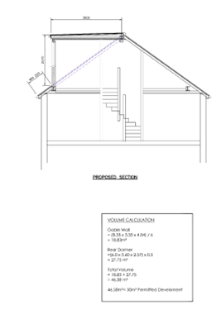

**This page has been left intentionally blank**